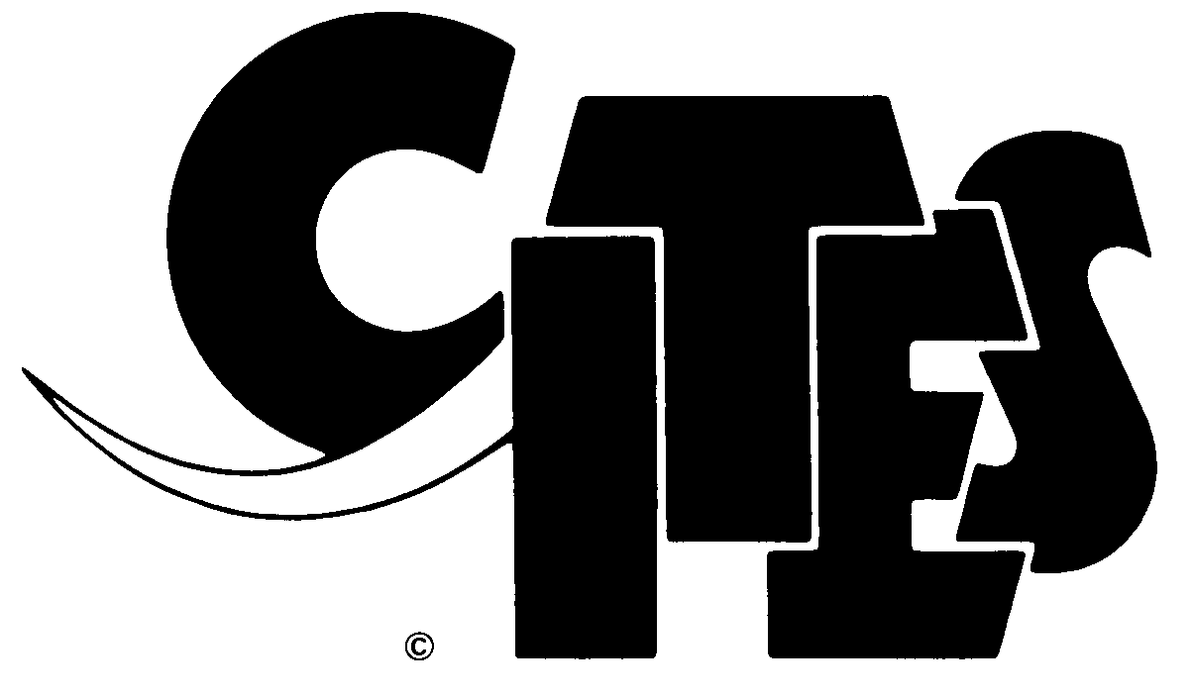
CONVENTION ON INTERNATIONAL TRADE IN ENDANGERED SPECIES
OF WILD FAUNA AND FLORA
____________________

Sixty-sixth meeting of the Standing Committee
Geneva (Switzerland), 11-15 January 2016

National laws for implementation of the Convention
According to the latest assessment 88 countries and 13 dependent territories need to strengthen their legal frameworks for the effective implementation of CITES, particularly to tackle illegal trade in wildlife.

 | National Legislation Project
 |  | 2015
 | Category | Parties | Percent
 | Category 1 | 88 | 48.6%
 | Category 2 | 49 | 27.1%
 | Category 3 | 39 | 21.5%
 | Pending | 5 | 2.8%
 | Total | 181 | 100.0%
Countries that require priority attention
The CITES National Legislation Project has identified 17 countries that require attention as a priority:
Algeria, Belize, Plurinational State of Bolivia, Comoros, Djibouti, Guinea-Bissau,
Kazakhstan, Kenya, Liberia, Mauritania, Mozambique, Pakistan, Paraguay, Rwanda,
Somalia, United Republic of Tanzania and Bolivarian Republic of Venezuela.
11 countries are in Africa, 4 in Central, South America and the Caribbean and 2 in Asia
The authorities of Belize, Plurinational State of Bolivia, Kazakhstan, Kenya, Mauritania, Mozambique, Pakistan and Paraguay have contacted the Secretariat to submit appropriate measures that have been drafted or adopted for effective implementation of the Convention, to inform of progress made or to request technical assistance.
The Standing Committee may wish to recommend that commercial trade in specimens of CITES-listed species be suspended with those Parties that required attention as a priority and have failed to adopt appropriate measures for the effective implementation of the Convention or agree an appropriate legislative timetable as required and that this recommendation take effect 60 days after the conclusion of SC66.
Parties that would be affected by this potential compliance measure are: Algeria, Comoros, Guinea-Bissau, Liberia, Rwanda, United Republic of Tanzania and Bolivarian Republic of Venezuela.

Disclaimer: Legislation enacted by non-Parties or territories that are under dispute or that are not recognized by the United Nations is not included in the NLP. Nothing in the NLP prejudices the claims and legal views of any Party concerning the legal status of any country, territory, or area, or concerning the delimitation of its frontiers or boundaries. The assessment of national legislation to implement CITES does not imply the expression of any opinion whatsoever on the part of the CITES Secretariat or the United Nations Environment Programme concerning those matters.

